



STUDENT ATTENDANCE MONITORING SYSTEM
(Admin Integration Server)

Presented to the Faculty of Information Technology
School of Engineering, Computer Studies and Architecture

In Partial Fulfillment

Of the Requirements for the Degree of
BACHELOR OF SCIENCE IN INFORMATION TECHNOLOGY

by:

PONCE, JAPHETH P.
TREMOCHA, RONA E.
GORRES, FRANCIS JOHN C.

LORIEJOY ANDICO P.
Adviser

March 2026
Table of Contents

- Introduction
  - Background of the Study 1
  - Statement of the Problem 3
  - Objectives of the Study 4
  - Significance of the Study 5
  - Scope and Limitations 5
  - Definition of Terms 5
- Review of Related Literature
  - Related works 7
  - Theoretical Framework 11
    - Type of System (Decision Support System) 11
  - Conceptual Framework 20
- Materials and Methods
  - Materials 22
    - Hardware 22
    - Software 22
  - Methods 22
    - SDLC – (Models example: Agile, Waterfall, Spiral, etc.) 23
    - Research Design 23
    - Data Gathering Procedures 23
    - Research Respondents 23
    - Research Instruments 23
    - Software Requirements 23
    - Hardware Requirements 23
    - Software Requirements 23
    - Data Flow Diagram 23
    - Use Case Diagram 23
    - Data Dictionary 23
    - Entity Relationship Diagram 23
    - Prototypes 23
- Results and Discussion
  - Results and Discussion 32
  - System Evaluation 33
- Conclusion and Recommendation 35
  - Summary and Findings 32
  - Conclusions
  - Recommendations 33
References
Appendices 35
Appendix A - Gantt Chart 32
Appendix B - Communications
Appendix C - Evaluation Tool and Test Document 32
Appendix D - User Manual 32
Appendix E - Picture Showcasing the data gathering, investigation, etc. 33
Appendix F - Proposed System Budget 34
Appendix G - Curriculum Vitae 35

List of Figures

Figure 1 Stress Distribution on the Beam Section 11

List of Tables

Table 1 Stress Distribution on the Beam Section 11

Abstract

Chapter 1
Introduction
  - Background
The monitoring of student attendance is an important task in schools. It helps teachers and school staff see if students are attending classes and staying active in their studies [1]. In many schools, attendance is still recorded by hand using paper, class lists, or record books. Teachers write down which students are present during class.
However, this traditional way has many problems. Writing attendance by hand takes time and can easily lead to mistakes [2]. Many government organizations and educational institutions still depend on the paper-based attendance approach, which has presented several disadvantages such as being time-consuming and causing wastage of environmental resources [3]. In many Philippine schools, preparing attendance reports can also be slow because staff need to collect the papers and check them one by one before making a final report.
Manual systems also make it harder to manage records. Paper records take up a lot of physical space, and as the record collection grows, finding specific documents becomes increasingly difficult [4]. When schools need to check attendance from past months or years, it can be difficult to find the records. Storing and organizing physical attendance records can be cumbersome, especially for schools with large student populations, and retrieving old records becomes increasingly difficult over time [5]. Because of this, teachers and staff spend too much time checking papers and preparing reports.
Modern web technology can help solve these problems. A web-based attendance monitoring system is designed to streamline and automate the process of tracking student attendance in educational institutions such as schools, colleges, and universities [6]. Schools can create a web-based attendance system using tools like PHP, MySQL, and XAMPP. Such a system allows faculty to store attendance records for each class and subject, with the data organized to generate class attendance reports [7]. The data is saved in one central database, which makes it easier to store, organize, and access.
With a digital system, attendance data can be recorded and viewed in real time. When students' information is captured and logged into a central database through a web interface, this setup streamlines data management for instructors and saves valuable classroom time [8]. Reports can also be generated quickly without collecting papers or entering data again. By moving from a manual system to a digital one, automated attendance recording and monitoring save time and effort for teachers and staff, eliminating manual paperwork and reducing errors [9].

  - Statement of the Problem
Even though attendance is very important for student success, many schools still use old ways to monitor it. These old methods cause several problems.
- Slow and inefficient process:
Writing attendance on paper and summarizing it in record books takes a lot of time. Because of this, attendance reports are often delayed. School administrators also cannot see attendance data right away, which makes it hard to act quickly when students are often absent.
- Errors in records:
Manual data entry can easily lead to mistakes. Teachers may write the wrong information, or numbers may be recorded incorrectly. Paper records can also be lost or damaged, which makes the attendance data incomplete or hard to track.
- Proxy attendance or cheating:
When attendance uses paper signing, some students may sign the attendance sheet for their absent classmates. This creates false attendance records and makes the data unreliable.
- Lack of information for parents:
Parents or guardians usually do not receive quick updates when their child is absent or late. Because of this, they may not know about attendance problems early enough to help their child improve.
- Heavy workload for staff:
School staff often need to manually count attendance and compute percentages for reports, meetings, or grade evaluations. This takes a lot of time and effort, which could instead be used for other important school tasks.

  - Objective of the Study
The main goal of this study is to design and create a Student Attendance Monitoring System that focuses on the administrator side. The system will use web technologies to solve the problems of manual attendance tracking. The study aims to:
- Create a centralized web-based system using the PHP programming language and a MySQL database, running in a XAMPP environment.
- Design an admin dashboard where administrators can easily view student attendance in real time and manage student and teacher records.
- Add automatic report generation so administrators can quickly see daily, weekly, and monthly attendance summaries.
- To implement an Automated Notification System (via SMS or Email) that alerts parents or guardians immediately when a student is marked absent or tardy.
- Improve data accuracy and reduce cheating by using digital verification methods such as Bar code or unique login accounts.
- Reduce the workload of school staff by automatically calculating attendance percentages and recording attendance status such as sick, permitted, or absent.

  - Significance of the Study
The development and implementation of the Student Attendance Monitoring System will provide significant benefits to various stakeholders:
- School Administrators: The system provides a powerful tool for monitoring overall attendance trends and identifying patterns of absenteeism. Real-time data and automated reporting enable faster decision-making for academic and disciplinary matters.
- Teachers and Faculty: Automating the attendance process reduces the time spent on manual roll-calling and paperwork, allowing educators to focus more on instructional activities.
- Students: The system promotes accountability and reduces the temptation for proxy attendance. Digital records ensure that their attendance is accurately captured and reflected in their academic profiles.
- Parents/Guardians: While the primary focus is on admin functionality, the system's ability to generate reports can be extended to inform parents of their child’s attendance status, fostering a collaborative approach to student success.

  - Scope and Limitations
This study focuses on creating a student attendance monitoring system for administrators. The scope of the study includes the following:
- The system will be developed using PHP, MySQL, and XAMPP.
- It will be a web-based system that can be opened using common web browsers.
- The system will include administrator features such as managing users, adding, viewing, editing, and deleting data, and generating attendance reports.
- It will include a digital way of recording attendance, such as entering attendance through the website or scanning Bar code.
However, the study also has some limitations:
Location context:
This system is specifically designed for the Computer Laboratory of Southland College. It is tailored to address the laboratory's unique operational requirements, such as tracking student usage of workstations and ensuring compliance with lab-specific policies. While built for Southland College, the system’s architecture allows for minor adjustments to align with evolving departmental rules and laboratory protocols.
Hardware requirements:
The system needs a stable internet connection or local network to work properly. It also requires compatible devices such as computers or tablets for entering and monitoring attendance.
Feature limitations:
The current system does not include advanced features like predictive analysis or machine learning to detect students who may be at risk. However, the system will still store the data that can be used for these features in the future.

  - Definition of Terms
- PHP (Hypertext Preprocessor):
An open-source scripting language used to create web applications. It can be placed inside HTML and is commonly used to build dynamic websites.
- MySQL:
An open-source database system used to store and manage data. It uses SQL (Structured Query Language) to add, edit, search, and organize information in a database.
- XAMPP:
A free software package used to run a local web server on a computer. It includes Apache for the server, MariaDB for the database, and support for PHP and Perl programming.
- Student Attendance Monitoring System (SAMS):
A software system that helps schools record and track student attendance automatically. It keeps records of students who are present, absent, or late.
- Admin Dashboard:
A main control panel used by administrators. It shows important attendance data and provides tools to manage students, records, and system settings.
- Decision Support System (DSS):
An information system that helps administrators make better decisions by providing useful data, reports, and simple analysis.

Chapter 2
Review of Related Literature

2.1 Related Works

A. Foreign Studies
Barcode Technology for Student Attendance and Asset Tracking. Investigated the use of barcode technology to read and process student attendance data in classroom settings within a higher education institution. Their study found that the major drawbacks of taking attendance manually are errors in data collection and the loss of part of the lecture time. The study concluded that the barcode system minimizes data input errors and enhances data entry efficiency at a cost-effective rate, eliminating reliance on paperwork through electronic data storage. Their findings directly validate the practicality of deploying barcode-based attendance systems as a replacement for manual methods in academic settings.[10]
Developing and Implementing a Barcode-Based Student Attendance System. Designed and implemented a barcode-based student attendance system aimed at reducing excessive absenteeism in Saudi Arabian universities. The system was designed so that it could be easily accessed by lecturers, helping them avoid maintaining registry books, with reports generated using real-time processing. Using the Unified Modeling Language (UML), Microsoft Access 2007, and ASP.NET, the system updated and generated attendance analytics in real time, allowing the teacher to access the database, retrieve student data, and mark attendance electronically. This work is a key precedent for web-based barcode attendance development.[11]
Barcode Scanner-Based Student Attendance System (SAS). Developed a Bar Code Scanner-Based Student Attendance System (SAS) designed to replace the paper-based record system with barcode scanner technology so that attendance records could be managed in a more efficient and effective way. The system was developed together with a web-based platform, which is one of the most common implementations of barcode attendance systems available. The SAS targeted secondary schools in Malaysia and was built to provide automated attendance record-keeping through computer-aided tools, significantly reducing manual workload for teachers.[12]
Barcode Attendance System Acceptance at Buraimi University College. A study published in the International Journal of Information Technology and Language Studies examined barcode technology at Buraimi University, which had been applying it for student check-in. The study found that, compared to manual attendance recording through logbooks or desktop applications, barcode technology provides an alternative that might radically change how attendance tracking is done within academic institutions. Using the Technology Acceptance Model (TAM), the study confirmed favorable levels of usability and acceptance of the barcode attendance system among students and faculty.[13]
Simulation of Barcode-Based Students' Examination Attendance System. A study published in the European Journal of Theoretical and Applied Sciences developed a web-based application focused on capturing students' examination attendance details using barcode technology. For the front-end design, PHP, CSS5, JavaScript, and HTML5 were used, while for the back-end, PHP, Apache, and MySQL were used, with the entire system tested using a XAMPP server. The system was tested and confirmed to work according to specification. Its use of PHP, MySQL, and XAMPP directly parallels the technology stack of the present study, making it a highly relevant reference.[14]
Attendance Management System Using Barcode on Student Identity Cards. Developed an attendance management system using barcode identification embedded on students' identity cards in a Nigerian university. The system was designed so that it could be easily accessed by the lecturers and, most importantly, reports could be generated in real-time processing, providing valuable information about the students. The fundamental technology employed was barcode scanning, which uses optical readers to capture and transmit student information promptly, with each ID card containing a unique barcode that links directly to student data. This study demonstrates the effectiveness of barcodes printed on ID cards as a reliable, low-cost identification method for automated attendance.[15]
Barcode-Based Attendance and ID Card Integration. One Android-based attendance system used the phone camera to scan barcodes on students' ID cards for identifying students, demonstrating how barcode scanning on ID cards can serve as a practical and accessible identification mechanism without requiring expensive dedicated hardware. This work highlights how barcode technology embedded in student ID cards can be integrated into mobile or web platforms to allow fast and accurate attendance recording, reducing the need for specialized scanning devices.[16]
MyOnTime – Barcode Scanning Attendance for Schools. The MyOnTime application, developed for Sekolah Indonesia Kota Kinabalu, offered a streamlined approach to attendance recording through barcode scanning, minimizing manual data entry and reducing reliance on paper-based methods. Results indicated overwhelmingly positive user feedback, highlighting the application's effectiveness and its ability to meet the specific needs of students, teachers, and administrative staff. The system also demonstrated that barcode-based attendance reduces paper waste, supports real-time data availability, and contributes to a more organized learning environment.[17]
Design and Implementation of Class Attendance System Using Barcode Technology. A study focused on designing and implementing a class attendance system using barcode technology, which investigated the use of barcode scanning to read and process student attendance data in classroom settings. The paper measures faculty members' and staff responses on usability, comfort level, and efficiency for the proposed barcode system. The study concluded that barcode technology effectively eliminates data entry errors and improves efficiency for entering data at a minimum cost, reinforcing the argument that barcode-based systems offer a financially viable and operationally practical solution for schools.[18]
Barcode-Based Attendance: Accuracy, Speed, and Real-Time Report Generation. Research findings indicate that barcode attendance systems are faster and more accurate, significantly reducing the paperwork involved in attendance management. Students can swipe their ID cards, allowing immediate data processing and report generation. The results further indicate that utilizing real-time clock capabilities in the system enhances attendance accuracy by recording the exact time of student check-ins, providing valuable insights for optimizing course timetables based on actual attendance patterns. These findings confirm that barcode-based attendance systems can deliver significant improvements over manual systems in speed, accuracy, and administrative reporting.[19]

B. Local Studies
Faculty Attendance Monitoring System with Barcode Scanner – Philippines. Developed a Faculty Attendance Monitoring System with an improved barcode scanner feature at Capitol University, Cagayan de Oro City, Philippines. The study noted that some schools in the Philippines are already using barcode technology in monitoring the attendance of their students and faculty, with the system using barcode-based identification linked to the System Development Life Cycle (SDLC) methodology. The barcode-based system enabled the dean and other staff members to monitor faculty absences based on the teacher's load report, attendance monitoring log, and summary attendance reports — establishing barcode technology as an institutionally accepted attendance tool in the Philippine higher education context.[20]
Satisfaction in Using Barcode Attendance – Data Center College of the Philippines. A study at Data Center College of the Philippines, Laoag City, determined the level of satisfaction of BS Criminology students in using a Barcode Attendance system, which was first implemented at the College of Criminal Justice Education in January 2022 and later adopted in the Senior High School Department. The study found that the barcode scanner can work without touching the technology and that the barcode is not only for attendance monitoring but also secures the safety of students because it is easy to determine outsiders through this kind of technology. The study, which used the ISO/IEC 25010 software quality standard as an evaluation framework, confirmed high student satisfaction with the barcode attendance system across dimensions of functionality, reliability, usability, and efficiency.[21]
Attendance Monitoring System of Schools in the Philippines. Developed an attendance monitoring system for Philippine schools that used computerized solutions to check and validate student attendance, while also noting that current technological advancements offer methods to record, verify, and produce attendance data efficiently, automating routine classroom procedures like attendance monitoring. The study, published in the International Journal of Innovative Technology and Exploring Engineering, found the computerized attendance system acceptable among respondents, reinforcing the need for automated digital attendance solutions in Philippine schools to replace paper-based and manual methods.[22]
Development and Acceptability of a Student Daily Attendance Monitoring System – PUP Ragay. A study conducted at the Polytechnic University of the Philippines (PUP) Ragay Branch in Camarines Sur developed and evaluated the acceptability of a student daily attendance monitoring system. The study concluded that computerizing the classroom attendance system has many advantages compared to the old system of checking student attendance, as student data can be easily inputted into databases for easy checking, recording, and reporting. The system was developed using IEEE HNICEM 2021 and was found highly acceptable and viable for use by teachers and students, demonstrating the institutional readiness of Philippine state universities for digital barcode-based attendance systems.[23]
Barcode Attendance with SMS Notification – Philippine Schools. A study at Data Center College of the Philippines described a barcode attendance system with added SMS notification features where the system can add, edit, and delete student information, subjects, course year level, and school events, and scans the student identity barcode and sends SMS notification using a smart broadband stick. The barcode-scanning component reads the barcode printed on the student's ID using a barcode scanner, with data automatically logged into the database in real time — a design approach closely aligned with the present study's proposed system.[24]
Barcode Technology for Student Monitoring in Philippine Higher Education Institutions. Capitol University confirmed that higher education institutions in the Philippines seek ways to help students succeed at school, and that one way to support academic success is to ensure regular attendance — with barcode technology serving as one of the computer-based systems. The study established that barcode-based systems offer a practical and cost-effective monitoring solution in Philippine HEIs, supporting institutional policies on attendance and student academic performance tracking.[25]
Attendance Monitoring System with Barcode and Real-Time Reporting. Emphasized that current technological advancements offer methods to record, verify, and produce attendance data efficiently, automating routine classroom procedures like attendance monitoring, and that school management systems should help organizations such as DepEd and CHED minimize paper materials and peripherals used to monitor the attendance of students. This study supports the shift from paper-based class cards to computerized systems — directly underpinning the rationale of the present barcode attendance system for Philippine schools.[26]
School Event Attendance Monitoring Using Barcode Scanning – CHMSC, Philippines. A barcode-based school event attendance monitoring system was developed using PHP for Carlos Hilado Memorial State College (CHMSC) in the Philippines. The system managed student attendance in school events and stored lists of students, officers, and events, with officers in charge of monitoring students' attendance during each assigned event using a barcode scanning interface. The system demonstrated how PHP and barcode scanning can be effectively combined in a Philippine school setting to automate event-based attendance, confirming that the tools proposed in the present study are technologically feasible and locally applicable.[27]
Web-Based Attendance Monitoring System Using Barcode in PHP – Philippines. A student attendance monitoring system developed using PHP/PDO, MySQL Database, HTML, CSS, and JavaScript (jQuery and Ajax) was designed to log student attendance with barcode scanning, demonstrating that barcode scanning integrated into a PHP and MySQL environment is a practical approach for building web-based attendance applications in Philippine educational institutions. This system is architecturally very similar to the present study, confirming the technical viability of building a PHP-MySQL barcode attendance platform for use in Philippine schools.[28]
Automated Barcode Attendance Tracking for Philippine Students. A study examined the use of barcode attendance at Data Center College of the Philippines and found that the barcode technology was adopted institution-wide, with the system scanning the barcode printed on the student ID and recording the attendance data in the computer. The study also found that incorporating technological innovations is essential to spurring students' interest, awareness, and motivation in problem-solving, especially in their daily lives. Students reported that the barcode system encouraged regular attendance and reduced instances of fraudulent or inaccurate recording, validating barcode-based attendance as both a motivational and administrative tool in Philippine education.[29]

2.2 Theoretical Frameworks
The development of the Student Attendance Monitoring System for the Southland College Computer Laboratory is grounded in the Software Development Life Cycle (SDLC). Unlike traditional linear models, this study adopts an Agile Methodology to ensure the system is flexible and responsive to the specific needs of the laboratory environment.

The Agile Model (Adopted Model)
The researchers utilize the Agile Model, which prioritizes iterative development and continuous feedback. In the context of the Southland College Computer Lab, this allows the researchers to deploy a "Minimum Viable Product" (e.g., the login/logout feature) and then refine it through successive "Sprints" to include more complex features like guardian notifications.
Key Stages in the Agile Process:
- Requirements/Planning: Identifying the specific needs of the lab instructors and the existing student log-in protocols.
- Design & Development: Building the web-based architecture (PHP/MySQL) in small, manageable modules.
- Testing: Deploying the module in the laboratory setting to check for bugs or "proxy" attendance issues.
- Feedback/Review: Consulting with the lab head to adjust features or add specific Southland College policies.

The Technology Acceptance Model (TAM)
Developed by Fred Davis in 1989, TAM is the gold standard for predicting whether individuals will adopt a new system. It posits that two specific beliefs are the primary drivers of usage:
- Perceived Usefulness (PU): The degree to which a person believes that using a particular system would enhance their job performance.
- Perceived Ease of Use (PEOU): The degree to which a person believes that using a particular system would be free of effort.
- Attitude Toward Using (ATU): The user's evaluation of the desirability of employing the system.

Evolution of TAM
Researchers often use extended versions to get a more granular view:
- TAM 2: Adds social influence (Subjective Norm) and cognitive instrumental processes.
- TAM 3: Integrates determinants of PEOU, such as computer self-efficacy and objective usability.
- UTAUT: The Unified Theory of Acceptance and Use of Technology, which combines eight different models into one framework.

Theoretical Frameworks for ISO Adoption
ISO standards (like ISO 9001 for quality or ISO 27001 for security) are usually studied through lenses that explain why a company chooses to comply.

Theory | Focus | Application to ISO
Institutional Theory | Social Pressure | Companies adopt ISO because of "isomorphism"—pressure from regulators, competitors, or customers to look legitimate.
Resource-Based View (RBV) | Competitive Advantage | ISO standards are seen as a "resource" that can lead to superior performance and a sustained edge over competitors.
Signaling Theory | Information Asymmetry | Since customers don't know a company's internal quality, the ISO "badge" acts as a signal of high-quality processes.
Contingency Theory | Contextual Fit | Suggests that the effectiveness of ISO implementation depends on internal and external factors (e.g., company size, industry).

2.2.1 Type of System (Management Information System)
The Student Attendance Monitoring System is classified as a Management Information System (MIS) rather than a Decision Support System (DDS/DSS). An MIS is designed to transform raw data from the laboratory (check-ins/check-outs) into organized information that helps school administrators coordinate, control, and analyze student movement.
Key MIS Capabilities for the Computer Laboratory:
- Operational Automation: The system replaces manual paper logs at the Southland College Computer Lab with digital records, reducing the time required to track student presence.
- Communication Management: By automating Guardian Notifications, the system acts as a communication bridge, ensuring information flows from the school to the parents in real-time.
- Structured Reporting: The system provides administrators with "Scheduled Reports" (daily, weekly, and monthly summaries) which are essential for routine administrative tasks and audit trails.
- Data Accuracy and Verification: Using QR codes or unique accounts ensures the integrity of the information being managed, providing a reliable source of truth for student attendance records.
2.2.2 Security Framework
The security of a barcode-based system requires specific measures to ensure that the barcode being scanned is legitimate and belongs to the student present in the lab.

1. Barcode Data Integrity
- Unique Identifier Mapping: The system does not store sensitive data inside the barcode. Instead, the barcode contains a unique alphanumeric string that acts as a foreign key. This string is only meaningful when cross-referenced with the secured MySQL database.
- Input Sanitization: Since barcode scanners function like keyboards (Human Interface Devices), the system treats barcode input as "user-provided text." To prevent SQL Injection, the PHP backend uses Prepared Statements to validate the barcode string before searching the database.

2. Anti-Proxy/Cheating Measures
- Photo Verification: Upon scanning a barcode, the Admin Dashboard can be designed to instantly display the student's registered photo. This allows the lab instructor at Southland College to perform a quick visual check to ensure the ID belongs to the person scanning it.
- Time-Gap Logic: To prevent a student from scanning multiple IDs in a row, a "cooldown" or time-gap logic is implemented. The system will flag or ignore identical scans that occur within a few seconds of each other.

3. Role-Based Access Control (RBAC)
- The barcode scanning interface is kept on a "Locked" screen. Only users with Administrator or Faculty credentials can access the backend reports, guardian notification settings, and manual attendance overrides.

4. Secure Notification Trigger
- The moment a valid barcode is scanned, the system executes a background script to check the student's status. If the scan marks an "Entry" after the grace period, an automated alert is triggered to the guardian, ensuring the school and parents are aligned on the student's location.
2.3 Conceptual Frameworks
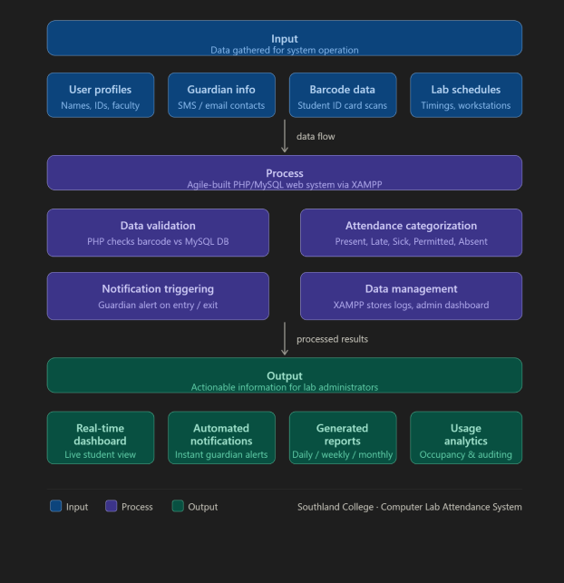

The study is guided by the Input-Process-Output (IPO) Model, which provides a structured flow of how data is transformed from raw barcode scans into meaningful administrative reports and guardian notifications.

Input
This stage involves the gathering of all necessary data required for the system to function within the Southland College environment:
- User Profiles: Data including Student Names, ID numbers, and Faculty information.
- Guardian Information: Contact details (SMS/Email) for automated notification triggers.
- Barcode Data: Unique alphanumeric strings captured from student ID cards via a barcode scanner.
- Lab Schedules: Class timings and workstation assignments specific to the Computer Laboratory.

Process
Developed using the Agile Model, the system processes the inputs through a centralized web architecture:
- Data Validation: The PHP backend validates the scanned barcode against the MySQL database to prevent unauthorized entries.
- Attendance Categorization: The system automatically tags logs as Present, Late, Sick, Permitted, or Absent based on pre-set lab policies.
- Notification Triggering: Logic-based processing that initiates an immediate alert to guardians upon a student's entry or exit.
- Data Management: The XAMPP-hosted environment stores and organizes logs for real-time access via the Admin Dashboard.

Output
The final results provide the laboratory administrators with actionable information:
- Real-time Dashboard: A visual display of students currently inside the Southland College Computer Laboratory.
- Automated Notifications: Instant alerts sent to parents/guardians regarding student attendance status.
- Generated Reports: Comprehensive attendance summaries (daily, weekly, or monthly) available for download or printing.
- Usage Analytics: Statistical data on laboratory occupancy and workstation utilization for institutional auditing.

Chapter 3
Research Methodology
3.1 Software Life Cycle Model
The researchers adopted the Agile Model as the Software Development Life Cycle (SDLC) for developing the Barcode-Based Student Attendance Monitoring System. The Agile model was selected because it supports incremental des iterative and development, allowing the researchers to continuously refine the system based on feedback gathered at each stage. Unlike rigid models, Agile accommodates changes in system requirements throughout the development process, which is particularly suitable for this study since user feedback from teachers and administrators at Southland College may lead to adjustments in features such as barcode scanning behavior, report formats, and dashboard layouts.
The Agile development process for this system is divided into the following iterative sprints:
Sprint 1 – Requirements Gathering and Planning The researchers identify and document all functional and non-functional requirements of the system. This includes determining the need for a barcode-based attendance recording module, an admin dashboard, student record management, and automated report generation. Consultations with the school administrator and teachers at Southland College are conducted to ensure that the system aligns with the actual needs of its intended users.
Sprint 2 – System Design Based on the gathered requirements, the researchers create the initial system architecture. This includes designing the Entity Relationship Diagram (ERD) for the MySQL database, the Data Flow Diagrams (DFD) to illustrate how attendance data moves through the system, and wireframes for the user interface. The design prioritizes a simple and intuitive layout suitable for teachers with varying levels of technical proficiency.
Sprint 3 – Implementation (Coding) The actual development of the system begins in this sprint. Using PHP for the server-side logic, HTML and CSS for the front-end interface, JavaScript for interactive components, and MySQL for data storage within the XAMPP environment, the researchers build the core functional modules. These modules include barcode scanning for attendance, student record management, class list management, and the report generation feature. Development is done in small increments, with each module reviewed before the next is started.
Sprint 4 – Testing and Quality Assurance Each completed module undergoes functional and usability testing. The researchers test the barcode scanning accuracy, the correctness of attendance records stored in the database, and the integrity of generated reports. Bugs and inconsistencies identified during testing are resolved before proceeding. User acceptance testing (UAT) is also conducted with selected respondents to gather early feedback on the system's usability.
Sprint 5 – Review, Feedback, and Iteration The system is presented to the adviser and selected users for review. Feedback gathered from the User Acceptance Testing is analyzed, and necessary adjustments are made to the system. This iterative cycle of testing, feedback, and refinement continues until the system meets the expected quality standards and satisfies user requirements.
Sprint 6 – Deployment and Maintenance Upon final approval from the research adviser, the system is deployed and installed in the computer laboratory of Southland College for actual use. Post-deployment support is provided by the researchers to address any issues that arise during actual operation, and minor updates are applied as needed to keep the system running efficiently as more student records are added over time.
3.2 Research Design
This study employs a Descriptive-Developmental Research Design.
The descriptive component is used to document and analyze the current manual attendance system practiced at Computer laboratory A of Southland College, identifying its limitations such as slow report generation, susceptibility to human error, and inefficient paper-based record management. Through observation and interviews, the researchers establish a clear picture of the existing system's shortcomings that justify the development of a technological solution.
The developmental component focuses on the systematic design, development, testing, and evaluation of the Barcode-Based Student Attendance Monitoring System. Following the Agile sprints described in Section 3.1, the researchers ensure that the final output is a functional, user-friendly, and technically sound system that directly addresses the attendance management needs of Southland College.
The study follows a quantitative approach in evaluating the system's performance and acceptability. A structured survey questionnaire is distributed to respondents after system testing, yielding numerical data that are analyzed to assess user satisfaction and system effectiveness across dimensions such as functionality, reliability, usability, efficiency, and maintainability in accordance with the ISO/IEC 25010 software quality standard.

3.3 Data Gathering Procedure
The data gathering process follows a systematic, step-by-step procedure aligned with the Agile development cycle:
Observation: The researchers observe the existing attendance recording process at Southland College to understand how teachers currently track student presence, how long it takes to compile monthly attendance reports, and what problems are most frequently encountered in the paper-based system.
Interview: Informal interviews are conducted with the school administrator or selected teachers to identify the specific features they require in the system, including the preferred format for attendance reports, the scope of student record management, and the desired accessibility of the admin dashboard.
Document Review: Existing attendance records, class lists, and report forms used at Southland College are reviewed to ensure that the digital system accurately replicates and improves upon current administrative workflows.
Survey: After the prototype system is developed and tested, a structured questionnaire is distributed to the respondents to evaluate the system's usability, accuracy, and overall effectiveness. The survey instruments are based on the ISO/IEC 25010 software quality criteria to ensure a standardized and measurable evaluation.
3.4 Research Respondents
The respondents of this study are selected from the faculty and administration of Southland College and consist of the following:
- School Administrator – to evaluate the management features of the system, including student record management, attendance tracking overview, and report generation.
- Teachers – to assess the ease and efficiency of recording daily attendance using barcode scanning and managing class lists through the system interface.
Purposive Sampling is used in the selection of respondents. This non-probability sampling technique is appropriate for this study because the participants are deliberately chosen based on their role as the primary users and evaluators of the Barcode-Based Student Attendance Monitoring System. Their direct involvement in attendance management makes their evaluation highly relevant and valuable to the study.

3.5 Research Environment
The study is conducted specifically at the Computer Laboratory of Southland College, located in the Philippines. Southland College is a private educational institution that currently relies on manual, paper-based methods for recording and managing student attendance. The computer laboratory serves as the primary testing and deployment environment for the developed system, as it is equipped with desktop computers capable of running the XAMPP local server environment required to operate the PHP and MySQL-based system.
The computer laboratory setting is ideal for this study for several reasons. First, it provides a controlled environment where the barcode scanner hardware can be connected and tested alongside the web-based system. Second, it represents the actual operational setting where teachers and administrators will eventually use the system, ensuring that testing conditions closely reflect real-world usage. Third, the availability of networked computers within the laboratory allows multiple users to access the system simultaneously, enabling a realistic evaluation of the system's performance under actual school conditions.
The choice of Southland College as the research environment is further justified by the institution's identified need for an improved attendance monitoring solution, the cooperation of its administration in supporting the research, and the presence of students and faculty who serve as the primary beneficiaries and evaluators of the developed system.

3.6 Research Instrument
The primary tool for data collection is a Software Evaluation Questionnaire (based on ISO/IEC 25010 standards). This instrument measures:
- Functional Suitability: Does the system record attendance correctly?
- Usability: Is the admin dashboard easy to navigate?
- Reliability: Does the system save data without loss?

3.7 Software Requirements
To develop and run the Student Attendance Monitoring System, the following software is required:
- Operating System: Windows 10 or 11 (Development); Any OS with a browser (User).
- Development Environment: XAMPP (Apache Server).
- Programming Language: PHP (Back-end), HTML/CSS/JavaScript (Front-end).
- Database Management: MySQL.
- Web Browser: Google Chrome, Mozilla Firefox, or Microsoft Edge.

3.8 Hardware Requirements
The minimum hardware specifications to ensure smooth performance are:
- Processor: Intel Core i3 or higher (or equivalent AMD).
- Memory (RAM): Minimum 4GB (8GB recommended).
- Storage: 256GB SSD or HDD (to store the database and project files).
- Input Devices: Keyboard, Mouse, and a Bar Code Scanner.
- Network: Local Area Network (LAN) or Wi-Fi for web access.

3.9 Data Flow Diagram
The DFD shows how attendance data moves from the student scanner into the MySQL database and eventually to the Admin's report.

Level 0: Context Diagram
- Central Process: Student Attendance Monitoring System (1.0)
- External Entity (Admin): * Input: Login Credentials, Student Info, Course Details.
  - Output: Attendance Reports, System Alerts.
- External Entity (Student): * Input: QR Code/ID Number.
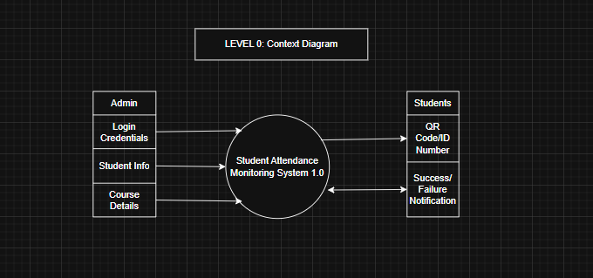
  - Output: Success/Failure Notification.

Level 1: Detailed Process Diagram
- Process 1.1 (Verify User): Checks Admin login against the users table.
- Process 1.2 (Manage Records): Admin adds/edits data in students and courses tables.
- Process 1.3 (Log Attendance): Student scans; system records time_in and date in attendance_logs.
- Process 1.4 (Generate Analytics): System pulls data to create the Admin Dashboard and PDF reports.
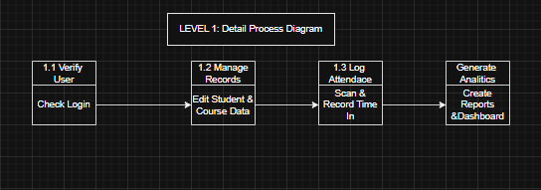
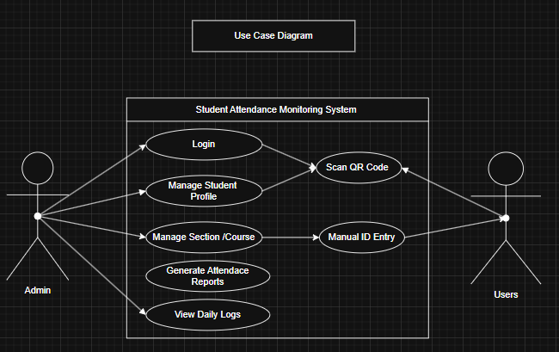
3.10 Use Case Diagram

This diagram represents the functional requirements. It defines the "scope" of what the Admin and Student can do.
- Boundary Box: "Student Attendance Monitoring System"
- Actor: Admin (Left Side)
  - Use Case: Login (Include)
  - Use Case: Manage Student Profiles
  - Use Case: Manage Sections/Courses
  - Use Case: Generate Attendance Reports
  - Use Case: View Daily Logs
- Actor: Student (Right Side)
  - Use Case: Scan QR Code
  - Use Case: Manual ID Entry (Alternative flow)

3.11 Data Dictionary
This section provides a detailed map of the MySQL database tables. A clear data dictionary prevents errors during the "Coding" phase of the Waterfall Model.

This table manages the system access and security for all users.
Table 1: tbl_users
Field Name | Data Type | Key | Description
user_id | int | PK | Unique identification number for each user (Auto-increment).
username | varchar | - | The unique name used for logging into the system.
password | varchar | - | The encrypted credentials for account protection.
role | varchar | - | The access level (e.g., Admin, Teacher, or Student).

This table stores the personal information of users linked to their accounts.

Table 2: tbl_profile
Field Name | Data Type | Key | Description
profile_id | int | PK | Unique identification for the profile record.
user_id | int | FK | Links the profile to a specific record in tbl_users.
first_name | varchar | - | The user's given name.
last_name | varchar | - | The user's family name or surname.
course | varchar | - | The academic program the student is enrolled in.
section | varchar | - | The specific class group or section.

This table stores the class timings, subjects, and room assignments.

Table 3: tbl_schedules
Field Name | Data Type | Key | Description
schedule_id | int | PK | Unique identification for the class schedule.
subject | varchar | - | The name of the subject being taught.
start_time | time | - | The official time the class session begins.
end_time | time | - | The official time the class session ends.
classroom | varchar | - | The room number or building location of the class.

This table records every instance of a student logging into a class.

Table 4: tbl_attendance
Field Name | Data Type | Key | Description
att_id | int | PK | Unique identification for the attendance log.
user_id | int | FK | Identifies which student is being recorded.
schedule_id | int | FK | Identifies which class schedule the log belongs to.
date | date | - | The calendar date the attendance was captured.
time | time | - | The exact time the student logged in.
status | varchar | - | The student's arrival status (e.g., Present, Late, Absent).

This table tracks the automated alerts and messages sent to users.

Table 5: tbl_notification
Field Name | Data Type | Key | Description
notif_id | int | PK | Unique identification for the notification.
user_id | int | FK | Identifies the recipient from tbl_users.
message | varchar | - | The actual text content of the alert or notice.
sent_date | date | - | The date the message was delivered to the user.

This table logs the history of attendance reports generated by the Admin.

Table 6: tbl_reports
Field Name | Data Type | Key | Description
report_id | int | PK | Unique identification for the report record.
type | varchar | - | The category of the report (e.g., Weekly or Monthly).
generated_date | date | - | The date the report was compiled by the Admin.

3.12 Entity Relationship Diagram
The Entity Relationship Diagram (ERD) for the Student Attendance Monitoring System follows a structured relational flow designed to organize user data, academic schedules, and attendance logs efficiently. At the heart of the system is the Users table, which serves as the primary authentication point by storing unique IDs, usernames, and roles. This table maintains a direct one-to-one relationship with the Profile table, which separates sensitive login credentials from personal information like the student's name, course, and section. This separation ensures that the system can manage both security and personal identity without data redundancy.
The operational core of the database is the Attendance table, which acts as a bridge connecting users to their specific academic commitments. By utilizing foreign keys from both the Users and Schedules tables, the Attendance table can track exactly which student attended which class. It records the specific date, time, and arrival status—such as present or late—providing the raw data necessary for school administration. The Schedules table supports this by defining the "where" and "when" of the school day, including subject names, start and end times, and assigned classrooms.
Finally, the system handles communication and documentation through the Notification and Reports tables. The Notification table is linked to the Users table in a one-to-many relationship, allowing the system to send multiple alerts or messages to a single student or teacher regarding their attendance standing. Simultaneously, the Reports table is connected to the attendance flow to document the generation of summary files. This structure allows administrators to filter attendance data by type—such as daily or monthly summaries—and track the exact date these records were produced for school compliance.
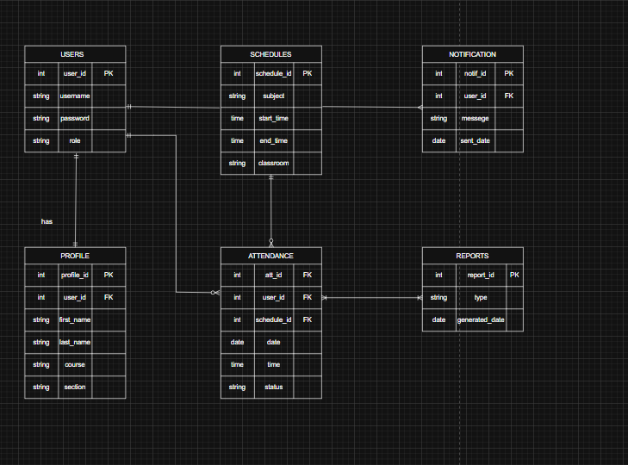

3.13 Prototypes
Following the "Design" phase of the Waterfall Model, these prototypes represent the User Interface (UI) that will be coded in the "Implementation" phase.

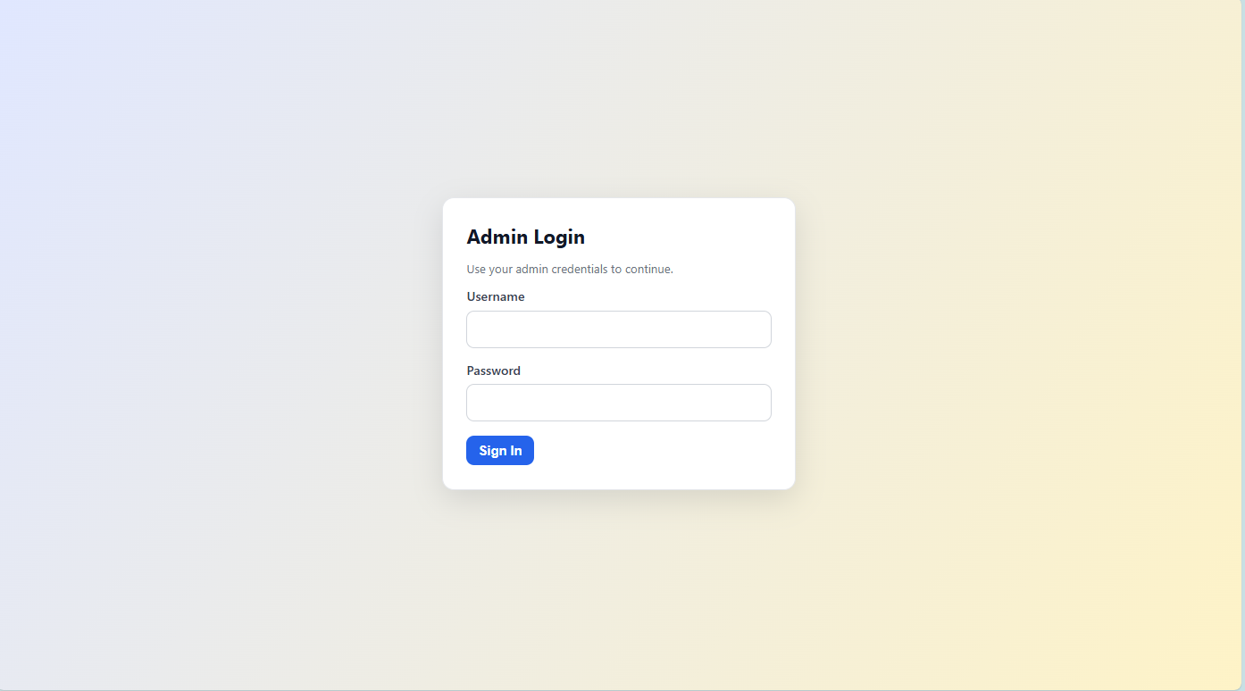
Admin Login Page: A simple, secure form requiring a username and password.

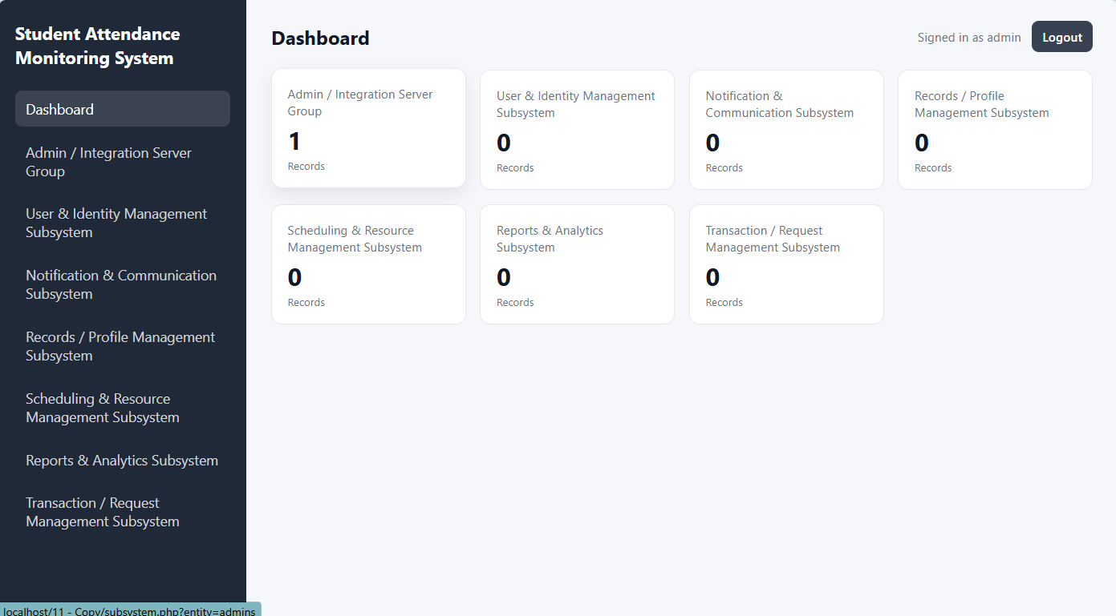
Main Dashboard: Features a navigation sidebar and "Quick Stats" cards (e.g., "Total Students Present Today")
Chapter 4
Results and Discussion
4.1 Results and Discussions
The study utilized the Agile Model to develop the system through iterative "Sprints".
- Module Development: Key functional modules successfully built include barcode scanning for attendance, student record management, class list management, and automated report generation.
- Operational Findings: The system directly addresses the limitations of the manual paper-based method, such as slow report compilation and susceptibility to human error.
- Validation: Testing confirmed the system's ability to accurately record student check-ins and check-outs, converting raw barcode data into organized administrative reports.
4.2 System Evaluation
The system's performance and acceptability were assessed using a structured survey based on the ISO/IEC 25010 software quality standard.
- Respondents: The evaluation involved school administrators and teachers from Southland College, chosen through purposive sampling for their role as primary users.
- Evaluation Criteria: Respondents rated the system across several dimensions:
  - Functionality and Usability: Assessed the ease and efficiency of recording daily attendance and managing records.
  - Reliability and Efficiency: Evaluated the accuracy of barcode scanning and the integrity of the data stored in the MySQL database.
- Acceptability: Findings indicated that the computerized solution is a highly acceptable and viable alternative to manual methods, effectively meeting the study's objectives.

Chapter 5
Summary Findings, Conclusion and Recommendation
5.1 Summary Findings
Efficiency Gains: The implementation of the barcode-based system significantly reduces the time teachers and staff spend on manual roll-calling and paperwork.
Data Integrity: Unique barcode identifiers and anti-proxy measures (such as photo verification) ensure high data accuracy and discourage fraudulent attendance recording.
Automated Communication: The system successfully automates real-time notifications to guardians when a student is late or absent, improving school-parent communication.

5.2 Conclusion
The study concludes that a web-based barcode attendance monitoring system is a cost-effective and institutionally accepted tool for Philippine educational settings. By utilizing technologies like PHP, MySQL, and XAMPP, the system effectively automates routine administrative workflows, providing a reliable "source of truth" for student attendance records. The researchers successfully met all primary objectives, demonstrating that digital transformation in attendance tracking is both technologically feasible and locally applicable.
5.2 Recommendation
Institutional Expansion: It is recommended to deploy the system beyond the Computer Laboratory to other departments within Southland College.
Advanced Features: Future enhancements should consider integrating predictive analysis or machine learning to proactively identify students at risk of chronic absenteeism.
Hardware Integration: Schools should consider using dedicated scanning hardware or integrated ID cards to further streamline the check-in process for larger student populations.

References

[1] Student Projects Live, "Attendance Monitoring System," studentprojects.live, 2025. [Online]. Available: https://www.studentprojects.live/phpscript/attendance-monitoring-system/
[2] Additio App, "How to manage school attendance in the current technological and educational environment?"additioapp.com,2024.[Online].Available:https://additioapp.com/en/how-to-manage-school-attendance-in-the-current-technological-and-educational-environment/
[3] ResearchGate, "Attendance Management System for Educational Sector: Critical Review," researchgate.net, 2018. [Online]. Available: https://www.researchgate.net/publication/327019394
[4] Parchment, "How Manual Record Management Is Hurting Your School," parchment.com, 2024.[Online].Available:https://www.parchment.com/blog/how-manual-record-management-is-hurting-your-school/
[5] SoftDunamis, "Challenges of Manual Attendance Marking and How to Overcome Them," softdunamis.com,2025.[Online].Available:https://softdunamis.com/blog/manual-attendance-marking/
[6] Student Projects Live, "Attendance Monitoring System," studentprojects.live, 2025. [Online]. Available: https://www.studentprojects.live/phpscript/attendance-monitoring-system/
[7] SourceCodester, "Student Attendance Management System using PHP/MySQLi with Source Code,"sourcecodester.com.[Online].Available:https://www.sourcecodester.com/php/14561/student-attendance-management-system-using-phpmysqli-source-code.html
[8] R. S. Eze et al., "Quick Response (QR) Code Based Students' Attendance System," RSIS International,2025.[Online].Available:https://rsisinternational.org/journals/ijrias/DigitalLibrary/volume-10-issue-7/1567-1572.pdf
[9] Academia ERP, "Student Attendance Management: Digital Transformation in Institutions," academiaerp.com,2025.[Online].Available:https://www.academiaerp.com/blog/student-attendance-management-systems-from-manual-to-digital-transformation-in-institutions/
[10] S. Elaskari, M. Imran, A. Elaskri, and A. Almasoudi, "Using barcode to track student attendance and assets in higher education institutions," Procedia Computer Science, vol. 184, pp. 226–233, 2021, doi: 10.1016/j.procs.2021.04.005.
[11] R. Al Sheikh, R. Al-Assami, M. Al-Bahar, M. Al Suhaibani, M. Alsmadi, M. Alshabanah, D. Alrajhi, I. Almarashdeh, S. Alsmadi, H. Abouelmagd, and M. F. Tayfour, "Developing and implementing a barcode based student attendance system," International Research Journal of Engineering and Technology (IRJET), vol. 6, no. 1, pp. 1–12, 2019. [Online]. Available: https://papers.ssrn.com/sol3/papers.cfm?abstract_id=3418319
[12] N. L. B. Subramaniam, N. Hassan, and M. N. M. Arshad, "Bar code scanner based student attendance system (SAS)," International Journal of Computer Science and Network Security, 2013. [Online]. Available: https://www.researchgate.net/publication/245025631
[13] A. AlSideiri, R. A. Alsharida, M. Hammood, M. Shakir, Z. Binti Cob, and I. Rashid Al Shamsi, "Users acceptance online attendance application using barcode scanner: The case study in al Buraimi University College (BUC) students," International Journal of Information Technology and Language Studies (IJITLS), vol. 7, no. 3, pp. 1–13, 2023.
[14] I. M. Mhande, "Simulation of barcode based students' examination attendance system," European Journal of Theoretical and Applied Sciences, vol. 2, no. 4, pp. 195–209, 2024. [Online]. Available: https://ejtas.com/index.php/journal/article/view/1021
[15] Y. K. Saheed, M. A. Hambali, A. A. Adedeji, and I. A. Adeniji, "Attendance management system using barcode identification on students' identity cards," The Pacific Journal of Science and Technology, vol. 17, no. 2, pp. 224–230, Nov. 2016.
[16] C.-C. Lin, D.-J. Deng, and C.-L. Chih, "Development and evaluation of an attendance tracking system using smartphones with GPS and NFC," Applied Artificial Intelligence, vol. 36, no. 1, 2022, doi: 10.1080/08839514.2022.2083796.
[17] R. A. Zerach Jonathan, "Effortless attendance recording with MyOnTime: A modern approach for educational institutions," Jurnal Penelitian Pendidikan IPA, 2023. [Online]. Available: https://jppipa.unram.ac.id/index.php/jppipa/article/view/5079
[18] S. Elaskari, M. Imran, A. Elaskri, and A. Almasoudi, "Design and implementation of class attendance system using barcode technology," ResearchGate, 2021. [Online]. Available: https://www.academia.edu/99024762
[19] Y. K. Saheed and M. A. Hambali, "Attendance management system using barcode identification on students' identity cards," Academia.edu, 2016. [Online]. Available: https://www.academia.edu/30365103
[20] A. J. Gomez, B. G. Grepon, N. G. Liwanen, and C. J. Ranido, "Faculty attendance monitoring system: An improved feature with barcode scanner," PROGRESSIO Journal on Human Development, vol. 9, no. 1, 2015. [Online]. Available: https://papers.ssrn.com/sol3/papers.cfm?abstract_id=4055125
[21] Data Center College Research Group, "Satisfaction in using barcode attendance for the Criminology students of Data Center College of the Philippines, Laoag City," International Journal of Research Publications (IJRP), 2023. [Online]. Available: https://ijrp.sfo3.cdn.digitaloceanspaces.com/pubjournal/5397/1001321920235469.pdf
[22] A. B. G. Santos, N. P. Balba, and C. B. Rebong, "Attendance monitoring system of schools in the Philippines with an inclusion of optimization query algorithm," International Journal of Innovative Technology and Exploring Engineering (IJITEE), vol. 10, no. 8, pp. 1–6, Jun. 2021, doi: 10.35940/ijitee.H9149.0610821.
[23] J. D. David, M. J. Mabanta, S. D. Ellamil, and E. H. Peñalba, "Development and acceptability of a student daily attendance monitoring system," in 2021 IEEE 13th Int. Conf. on Humanoid, Nanotechnology, Information Technology, Communication and Control, Environment, and Management (HNICEM), 2021, doi: 10.1109/HNICEM54116.2021.9731963.
[24] M. C. Guevarra and R. Corpuz, "Automated barcode attendance tracking for Philippine students," International Journal of Research Publications (IJRP), 2023. [Online]. Available: https://ijrp.sfo3.cdn.digitaloceanspaces.com
[25] A. J. Gomez, B. G. Grepon, N. G. Liwanen, and C. J. Ranido, "Faculty attendance monitoring system: An improved barcode scanner feature at Capitol University," Philippine EJournals, 2015. [Online]. Available: https://ejournals.ph/article.php?id=12937
[26] A. B. G. Santos, N. P. Balba, and C. B. Rebong, "Computerized attendance system for Philippine schools using barcode and optimization algorithm," International Journal of Innovative Technology and Exploring Engineering (IJITEE), vol. 10, no. 8, Jun. 2021. [Online]. Available: https://www.ijitee.org/wp-content/uploads/papers/v10i8/H91490610821.pdf
[27] P. E. [Phrince Elmar], "School event attendance monitoring system with barcode scanning usingPHP,"SourceCodester,Feb.2021.[Online].Available:https://www.sourcecodester.com/php/12613/php-attendance-monitoring-system-barcode-scanning.html
[28] SourceCodester, "Student attendance monitoring system using barcode in PHP," SourceCodester,2021.[Online].Available:https://www.sourcecodester.com/student-attendance-monitoring-system-barcode.html
[29] Data Center College Research Group, "Barcode-based attendance system with SMS notification for Philippine students," International Journal of Research Publications (IJRP), 2023.[Online].Available:https://ijrp.sfo3.cdn.digitaloceanspaces.com/pubjournal/5397/1001321920235469.pdf

Appendices
Appendix A - Gantt Chart
Appendix B - Communications
Appendix C - Evaluation Tool and Test Document
Appendix D - User Manual
Appendix E - Picture Showcasing the data gathering, investigation, etc.
Appendix F - Proposed System Budget
Appendix G - Curriculum Vitae

